Home Page Section

- Text Size Smaller “Advanced…Solutions” to be like https://www.halton.com/ website
- Align all together & use the same space on the left & right
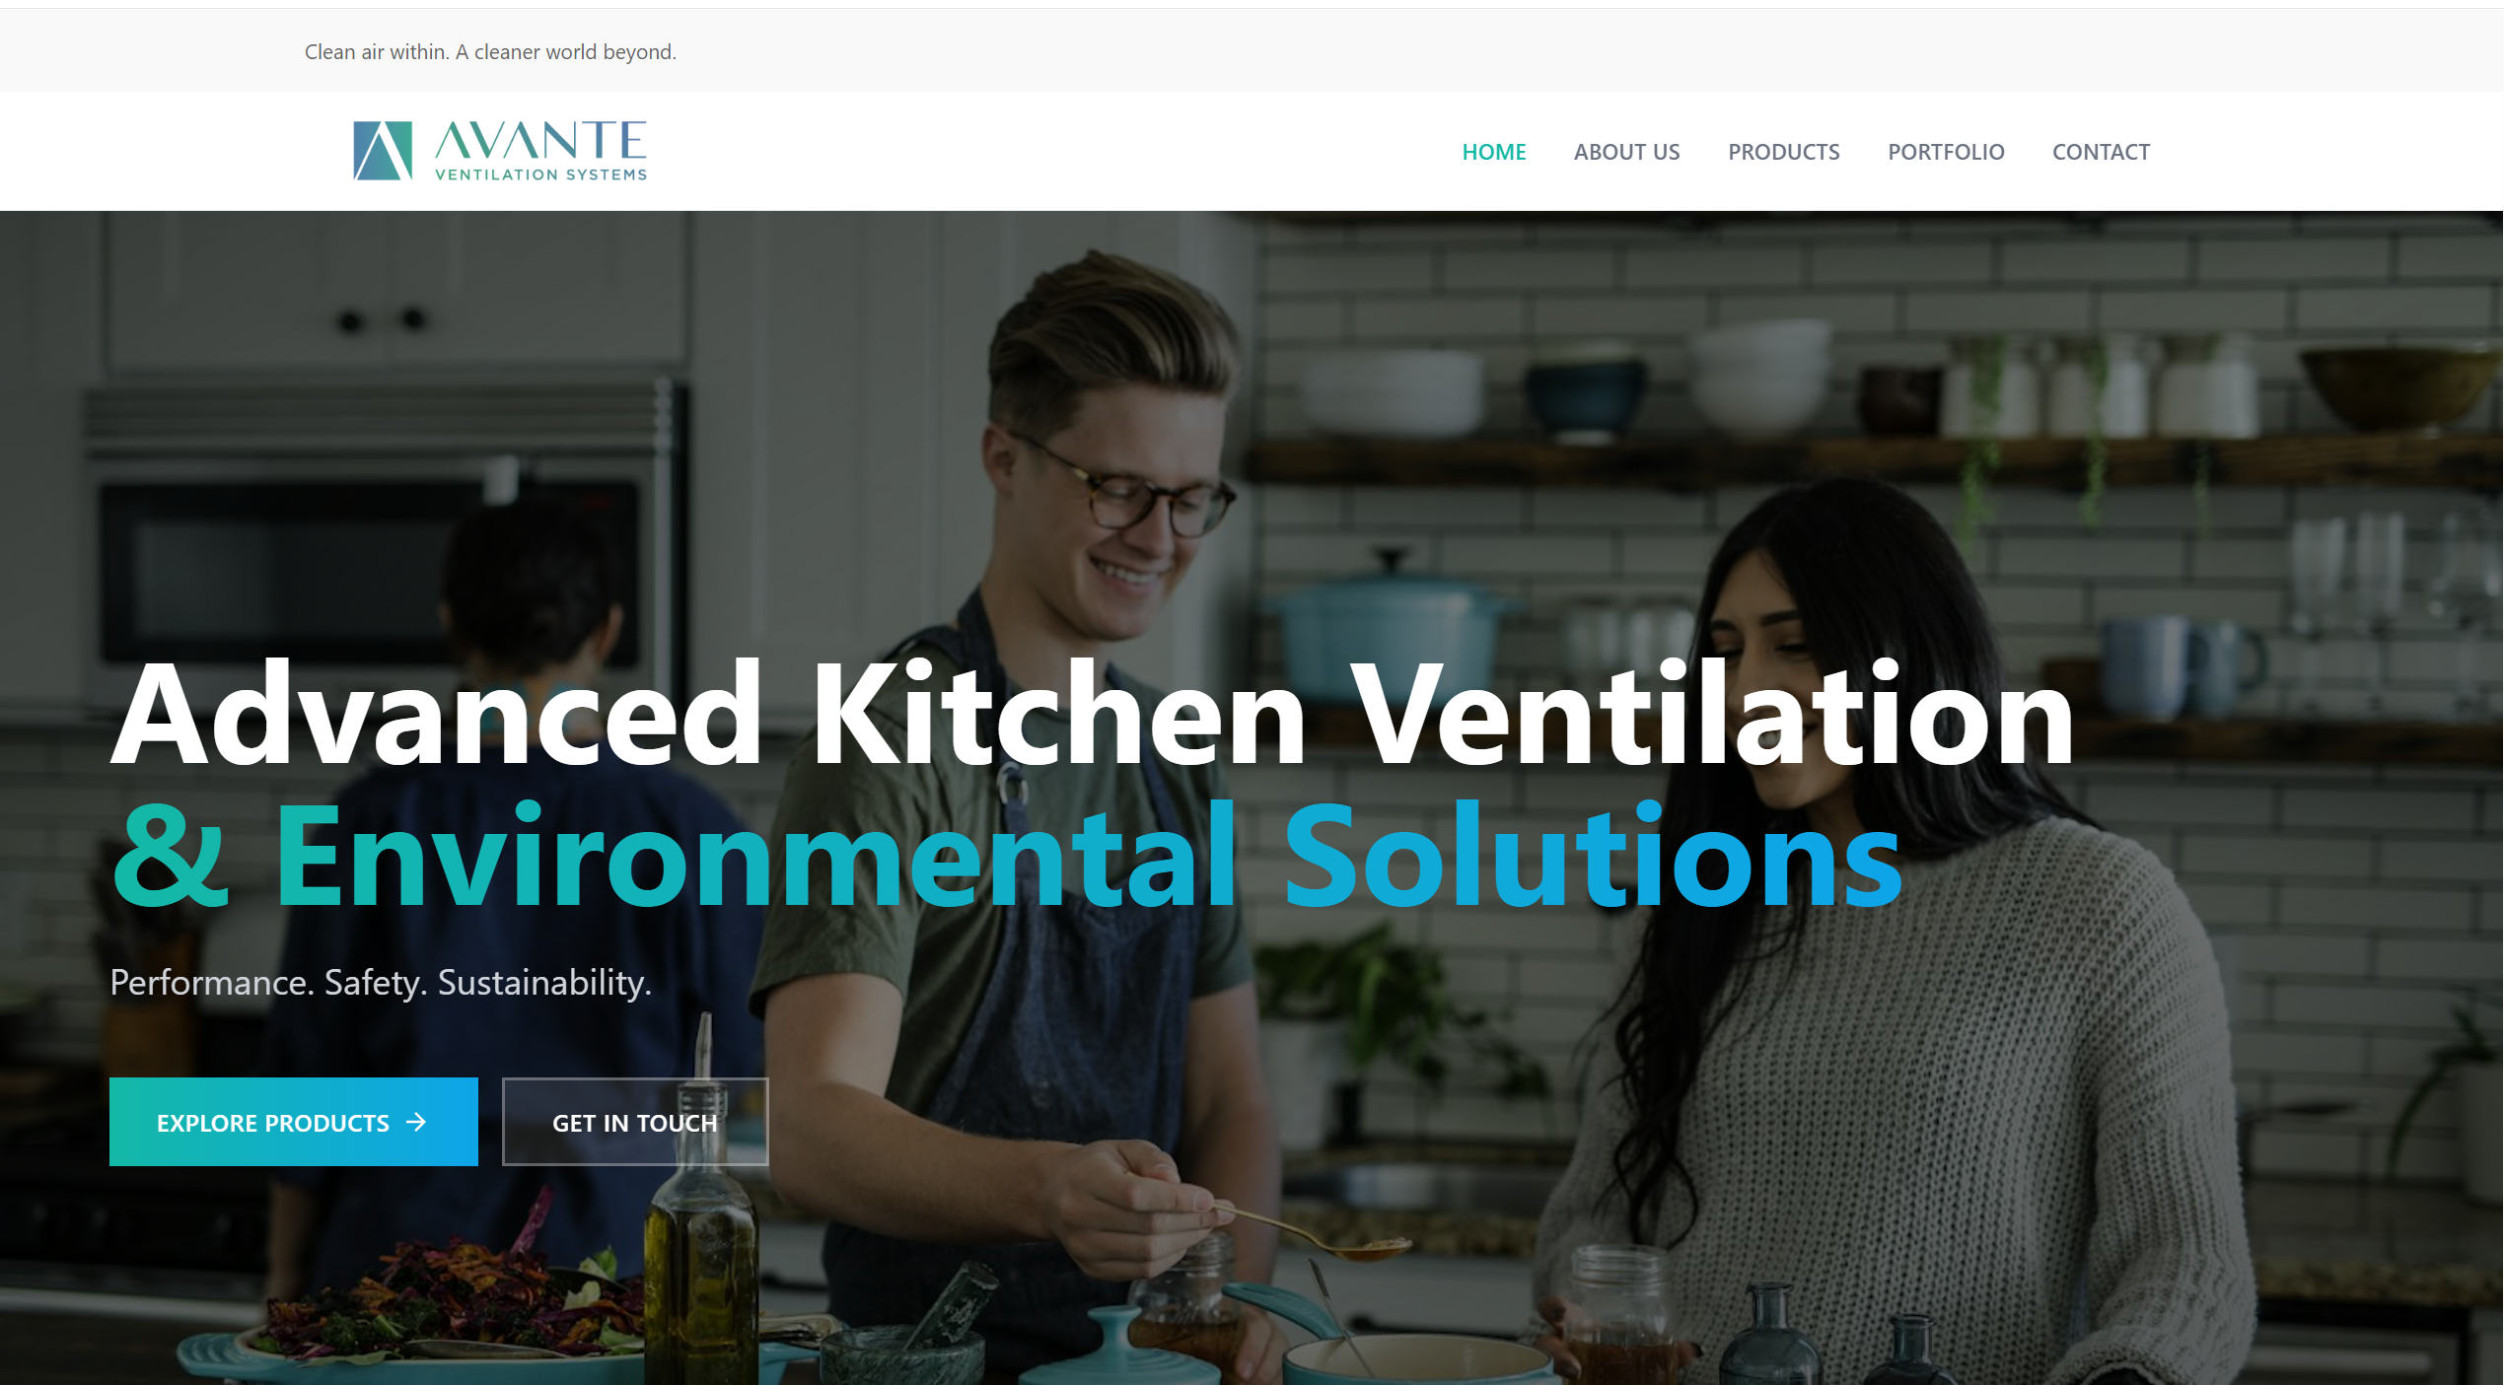

- Adjust info
+971 4 2392882 | sales@avanteuae.com
Correct Logo
Advanced Kitchen Ventilation & Environmental Solutions
Dubai Investment Park – 2, UAE
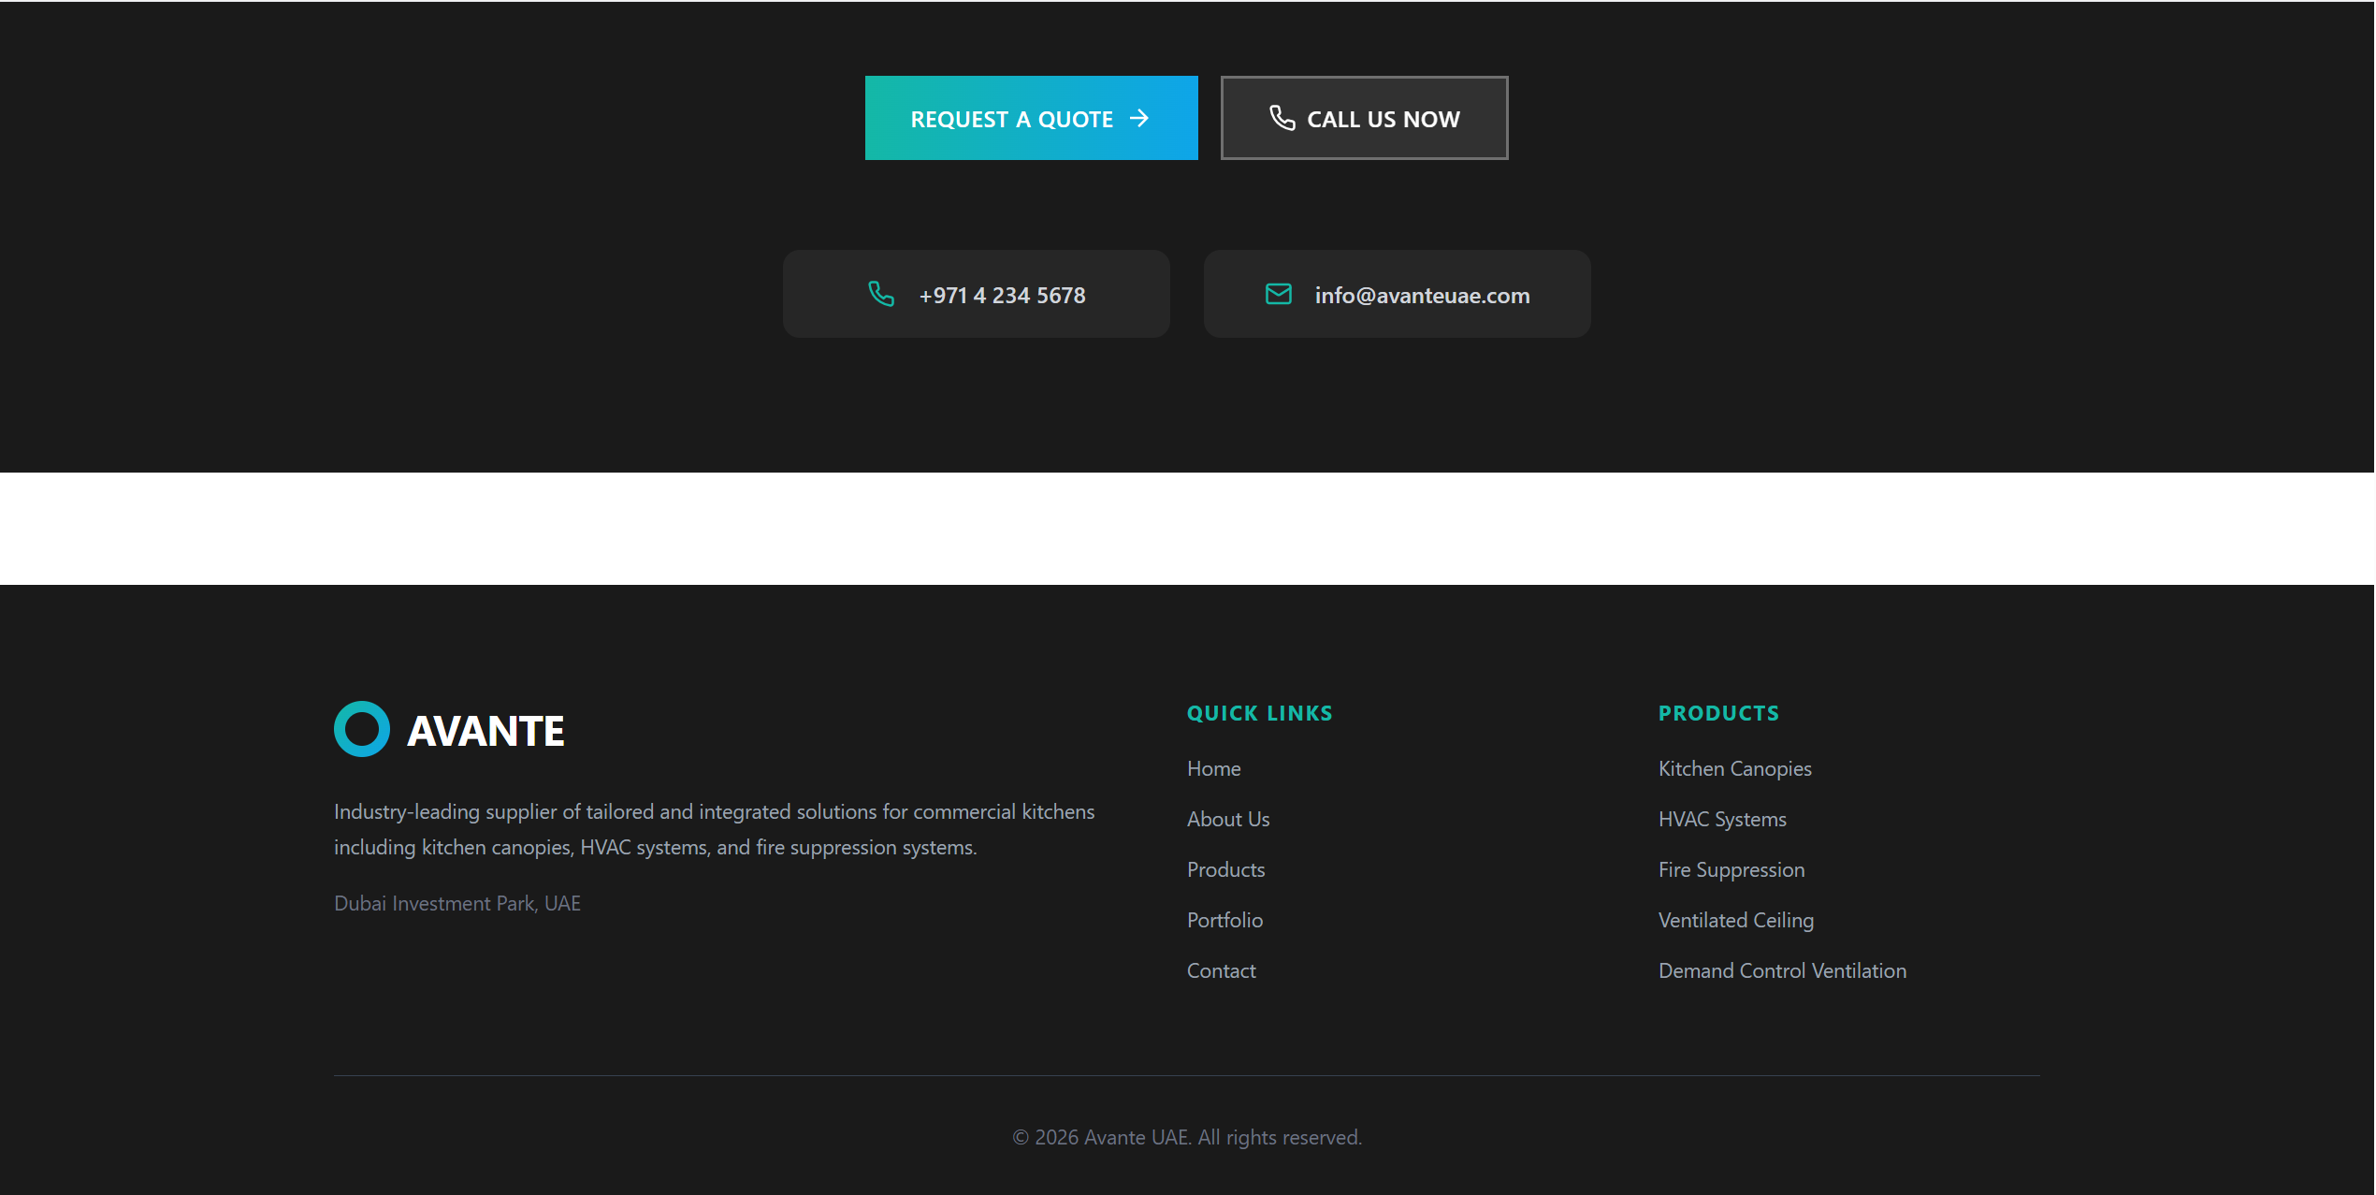

- Start with About Us page & move “Why choose us” & the “Certifications” sections there
- Start with Contact page & use sales@avanteuae.com for the email

